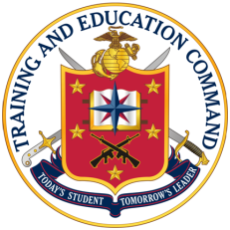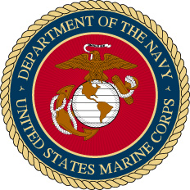

**Questions, comments, or corrections should be directed to TECOM G-3 (Operations Branch), TECOM G3 Operations Branch: 703-784-1429**

* Solid connecting lines indicate chain of command.
* Dashed connecting lines indicate ADCON of either the activity or the USMC personnel assigned thereto, or mission oversight by the senior activity.



|  |
| --- |
| **MARINE CORPS REPRESENTATIVES** |
| USMC Liaison, Communication Cable & Systems, Sheppard AFB, TX |
| USMC Representative, USAF Special Operations School, Hurlbert Field, FL |
| USMC Representative, Defense Acquisition University, Fort Belvoir, VA |
| USMC Representative, SOCOM, Fort Bragg, NC |
| USMC Representative, USA Transportation School, Fort Eustis, VA |
| USMC Representative, JAG School, Charlottesville, VA |
| USMC Liaison, Navy Dive School, Panama City, FL |
| USMC Representative, SERE School, NAS Coronado, CA |
| USMC Representative, SERE School, Portsmouth Naval Shipyard, NH |
| USMC Liaison, Advance Electronic School, NB San Diego, CA |
| USMC Instructor, Fleet Training Center, Norfolk, VA |
| USMC Representative, Air University, Maxwell AFB, AL |
| USMC Representative, USA War College, Carlisle, PA |
| USMC Representative, Naval War College, Newport, RI |
| USMC Representative, Naval Post Graduate School, Monterey, CA |
| USMC Representative, National Defense University, Fort McNair, DC |
| USMC Instructor, Multi-TADL, Fort Bragg, NC |
| USMC Postal Officer, Postal School, Fort Jackson, SC |
| USMC Representative, Def Threat Reduction Agency, Kirtland AFB, NM |